**Q1) Develop a Menu driven program to demonstrate the following operations of Arrays  
——MENU——- 1.CREATE  
2. DISPLAY  
3. INSERT  
4. DELETE  
5. LINEAR SEARCH  
6. EXIT**

#include <iostream>

using namespace std;

int main () {

int s;

cout<<"Enter size"<<endl;

cin>>s;

s=s+1;

int arr[s];

int n;

do {

cout<<"Enter choice"<<endl;

cout<<"1 for Creation"<<endl<<"2 for Display"<<endl<<"3 for Insert"<<endl<<"4 for Delete"<<endl<<"5 for Linear Search"<<endl<<"6 for Exit"<<endl;

cin>>n;

switch(n)

{

case 1:

{

cout<<"Enter elements"<<endl;

for (int i=0; i<s-1; i++)

cin>>arr[i];

break;

}

case 2:

{

for (int i=0; i<s-1; i++)

cout<<arr[i]<<" ";

cout<<"\n";

break;

}

case 3:

{

int e,p;

cout<<"Enter element and pos"<<endl;

cin>>e;

cin>>p;

for (int i=s-1; i>p; i--)

arr[i]=arr[i-1];

arr[p]=e;

for(int i=0; i<s; i++)

cout<<arr[i]<<" ";

cout<<"\n";

break;

}

case 4:

{

int d;

cout<<"Enter pos"<<endl;

for (int i=d; i<s-1; i++)

arr[i]=arr[i+1];

for (int i=0; i<s-1; i++)

cout<<arr[i]<<" ";

cout<<"\n";

break;

}

case 5 :

{

int e,flag,i;

cout<<"enter element"<<endl;

cin>>e;

for( i=0;i<s-1;i++)

{

if(arr[i]==e)

{

flag=1;

break;

}

}

if(flag==1)

{

cout<<"element found at "<<i<<endl;

}

else

cout<<"not found"<<endl;

}

case 6:

{

cout<<"Exit";

break;

}

default:

{

cout<<"Wrong choice";

}

}

}

while(n!=6);

return 0;

}

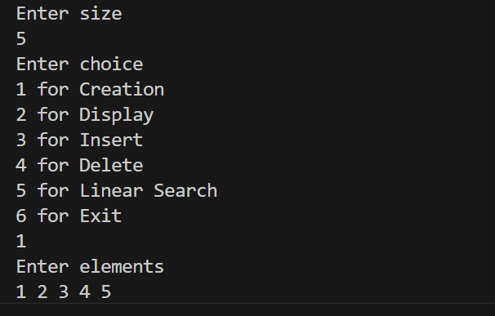

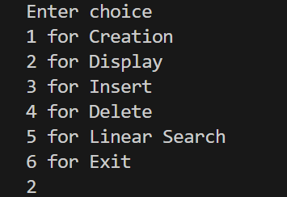

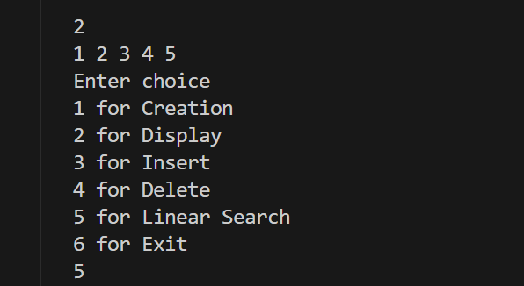

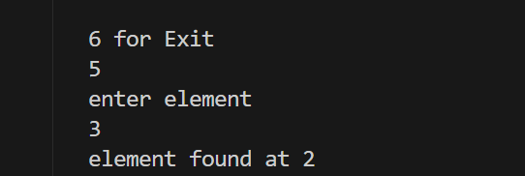

**Q2) Design the logic to remove the duplicate elements from an Array and after the deletion the array should contain the unique elements.**

#include<iostream>

using namespace std;

int duplicate(int arr[],int n)

{

int i=0;

for(int j=1;j<n;j++)

{

if(arr[i]!=arr[j])

{

arr[i+1]=arr[j];

i++;

}

}

return i;

}

int main()

{

int n;

cout<<"enter array size"<<endl;

cin>>n;

int arr[n];

cout<<"enter sorted array"<<endl;

for(int i=0;i<n;i++)

cin>>arr[i];

int r=duplicate(arr,n);

r++;

cout<<r<<" unique elements"<<endl;

for(int i=0;i<r;i++)

cout<<arr[i]<<"";

}

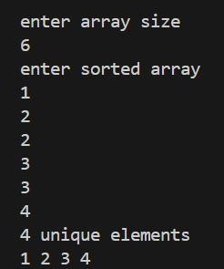

**Q3) Predict the Output of the following program  
int main()  
{  
int i;  
int arr[5] = {1};  
for (i = 0; i < 5; i++) printf("%d",arr[i]);  
return 0;  
}**

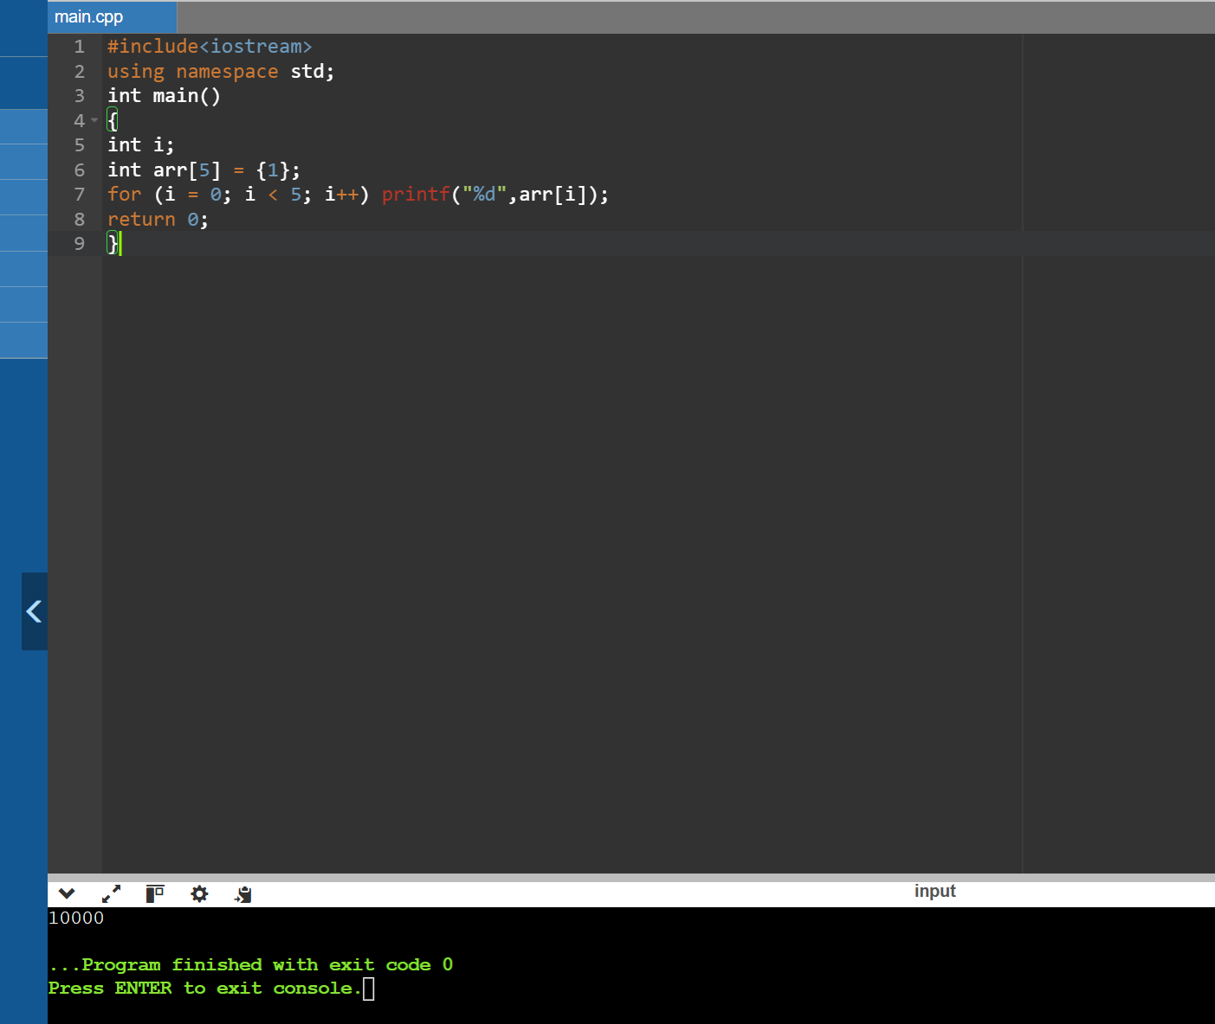

**Q4) Implement the logic to:-  
a. Reverse the elements of an array**

#include<iostream>

using namespace std;

int main()

{

int n;

cout<<"enter array size"<<endl;

cin>>n;

int arr[n];

cout<<"enter array"<<endl;

for(int i=0;i<n;i++)

cin>>arr[i];

int start,temp,end;

start=0,end=n-1;

while(start<=end)

{

temp=arr[start];

arr[start]=arr[end];

arr[end]=temp;

start++;

end--;

}

for(int i=0;i<n;i++)

cout<<arr[i]<<"";

}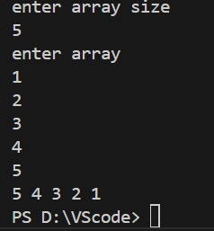

**b. Find the matrix multiplication**

#include<iostream>

using namespace std;

int main()

{

int r1,c1;

cout<<"enter rows and columns"<<endl;

cin>>r1;

cin>>c1;

int arr[r1][c1];

cout<<"enter matrix"<<endl;

for(int i=0;i<r1;i++)

{

for(int j=0;j<c1;j++)

{

cin>>arr[i][j];

}

}

for(int i=0;i<r1;i++)

{

for(int j=0;j<c1;j++)

{

cout<<arr[i][j]<<" ";

}

cout<<endl;

}

int r2,c2;

cout<<"enter rows and columns"<<endl;

cin>>r2;

cin>>c2;

int brr[r2][c2];

cout<<"enter matrix"<<endl;

for(int i=0;i<r2;i++)

{

for(int j=0;j<c2;j++)

{

cin>>brr[i][j];

}

}

for(int i=0;i<r2;i++)

{

for(int j=0;j<c2;j++)

{

cout<<brr[i][j]<<" ";

}

cout<<endl;

}

if(c1!=r2)

cout<<"multiply not possible"<<endl;

else

{

int crr[r1][c2];

for(int i=0;i<r1;i++)

{

for(int j=0;j<c2;j++)

{

crr[i][j]=0;

for(int k=0;k<c1;k++)

{

crr[i][j]+=arr[i][k]*brr[k][j];

}

}

}

cout<<"multiplied matrix"<<endl;

for(int i=0;i<r1;i++)

{

for(int j=0;j<c2;j++)

{

cout<<crr[i][j]<<" ";

}

cout<<endl;

}

}

return 0;

}

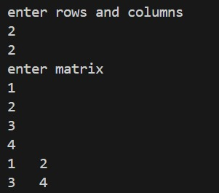

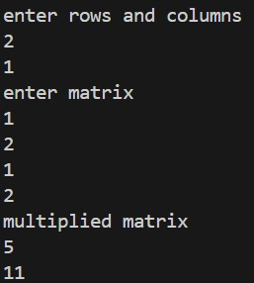

**c. Find the Transpose of a Matrix**

#include <iostream>

using namespace std;

int main() {

int r, c;

cout << "Enter number of rows: ";

cin >> r;

cout << "Enter number of columns: ";

cin >> c;

int matrix[r][c], transpose[c][r];

cout << "Enter elements of the matrix:\n";

for (int i = 0; i < r; i++) {

for (int j = 0; j < c; j++) {

cin >> matrix[i][j];

}

}

for (int i = 0; i < r; i++) {

for (int j = 0; j < c; j++) {

transpose[j][i] = matrix[i][j];

}

}

cout << "\nTranspose of the matrix:\n";

for (int i = 0; i < c; i++) {

for (int j = 0; j < r; j++) {

cout << transpose[i][j] << " ";

}

cout << endl;

}

return 0;

}

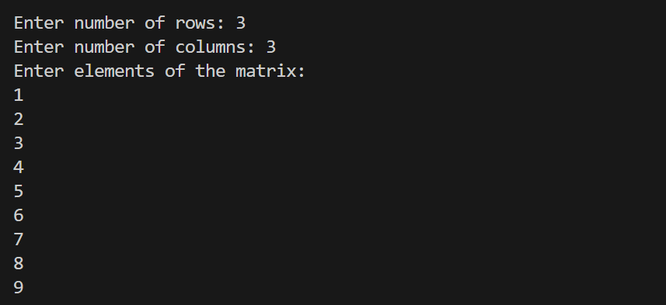

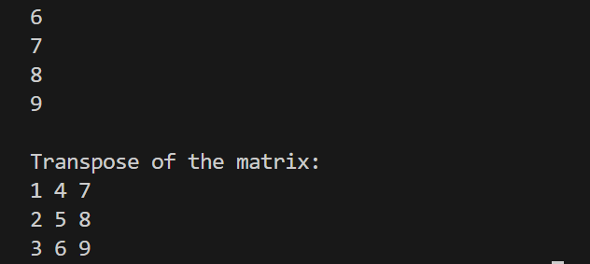

**Q5) Write a program to find sum of every row and every column in a two-dimensional array.**

#include<iostream>

using namespace std;

int main()

{

int r,c;

int sr,sc;

cout<<"enter rows and columns"<<endl;

cin>>r;

cin>>c;

int arr[r][c];

cout<<"enter matrix"<<endl;

for(int i=0;i<r;i++)

{

for(int j=0;j<c;j++)

{

cin>>arr[i][j];

}

}

for(int i=0;i<r;i++)

{

for(int j=0;j<c;j++)

{

cout<<arr[i][j]<<" ";

}

cout<<endl;

}

for(int i=0;i<r;i++)

{

sr=0;

for(int j=0;j<c;j++)

{

sr=sr+arr[i][j];

}

cout<<"sum of "<<(i+1)<<" row ="<<sr<<endl;

}

for(int j=0;j<c;j++)

{

sc=0;

for(int i=0;i<r;i++)

{

sc=sc+arr[i][j];

}

cout<<"sum of "<<(j+1)<<" column ="<<sc<<endl;

}

}

